**Workflow Timers**

The Workflow Timers are used to set “time designations” for automatic notifications sent from the system. Below is a screenshot of the default/most recommended selections. Please review and let us know if you would like to change any of the values. Once the initial notifications are sent, they will continually go out daily until action is taken.

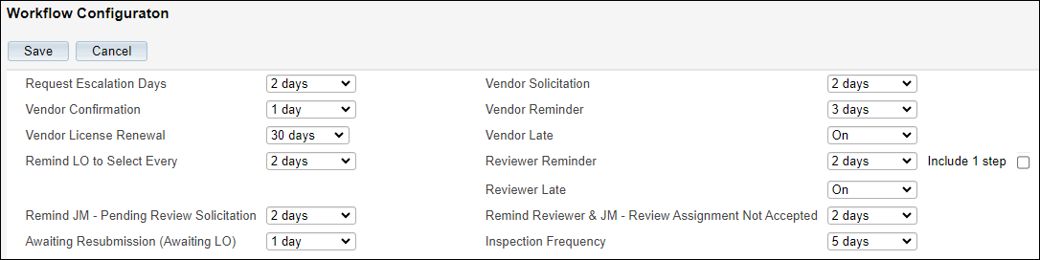

1. **Request Escalation Days: **If you are set up to route using Assigned Area and all of your orders are routed to 1 email address this will NOT apply to you and you can skip\*\***

The # of days/months before a Request is escalated if not Accepted by the original assigned Job Manager.An Escalation Processor (Job Manager) must be set in the Assigned Area for the Request Escalation to occur.The *Appraisal Request Unanswered* email will automatically be sent to the original Job Manager, notifying them that the Request has been escalated. The Request will continue to be escalated between the original Job Manager and the Escalation Job Manager until the Request is Accepted.

1. **Vendor Confirmation:** The # of days a vendor has to confirm an engagement offer. This is presented in the *Vendor Confirmation* email provided once the Job Manager has selected them for engagement. If the vendor does not confirm their acceptance within the # of days, the system will automatically send the *Vendor No Acknowledgement* email to the Vendor AND the Job Manager to remind them that the confirmation is still outstanding.

NOTE: There is not an automatic rescinding of the engagement offer after this # of days has passed; however, the Job Manager could offer the engagement to another vendor, and the initial vendor will be sent the *Vendor Lost Bid* email that the engagement offer has been rescinded.

1. **Vendor License Renewal:** The # of days before credential expiration, the *Vendor License Renewal* email is sent to the Vendor. **We recommend this be set to 20 days**
2. **Remind LO to Select Every:** The # of days to remind a Loan Officer to select a Bid provided to them by the Job Manager by utilizing the LO Bid Selection workflow button. A daily reminder will be sent after the initial email until a bid is selected.
3. **Remind JM – Pending Review Solicitation:** The *No Review Solicitation Responses Reminder* email is sent to the JM when no Review Solicitation responses have been received. Applicable when soliciting an external reviewer.
4. **Awaiting Resubmission (Awaiting LO):** After initial rejection by the JM of a newly submitted order due to insufficient information – Loan Officer receives *Request Resubmission Reminder* email notification reminding them to resubmit request.
5. **Vendor Solicitation:** Once you send a Bid Solicitation and the # of days have passed, the system sends a notification to the Job Manager that no bids have been received. This allows the Job Manager to contact the existing bidders to find out why they have not responded or solicit additional vendors.
6. **Vendor Reminder:** The # of days before the Report Due Date, the automatic *Vendor Report Reminder* notification email is sent to the vendor.
7. **Vendor Late:** Enables/disables the “Past Due” notifications sent out to Vendors.   
   When enabled, notifications are sent on the next business day after the Revised Report Delivery Date and will continue to be sent until the report is uploaded or the delivery date is extended.
8. **Reviewer Reminder:** The # of days before the Review Due Date, the automatic *Review Reminder* email is sent to the Reviewer (Internal or External Reviewer).
   * **Include 1 Step** – if checked, the reminder will also be sent on 1-Step Review-only orders.
9. **Reviewer Late:** Enables/disables the “Past Due” notifications sent out to Reviewers (Internal or External). When enabled, notifications are sent on the next business day after the Review Due Date and will continue to be sent until the review is completed or the due date is extended.
10. **Remind Reviewer & JM – Review Assignment Not Accepted:** The# of days before the Reviewer and Job Manager are sent the email to remind the Reviewer (Internal or external) to accept the Review Assignment.
11. **Inspection Frequency** – N/A